SQL Hints

sp_who2
sp_monitor
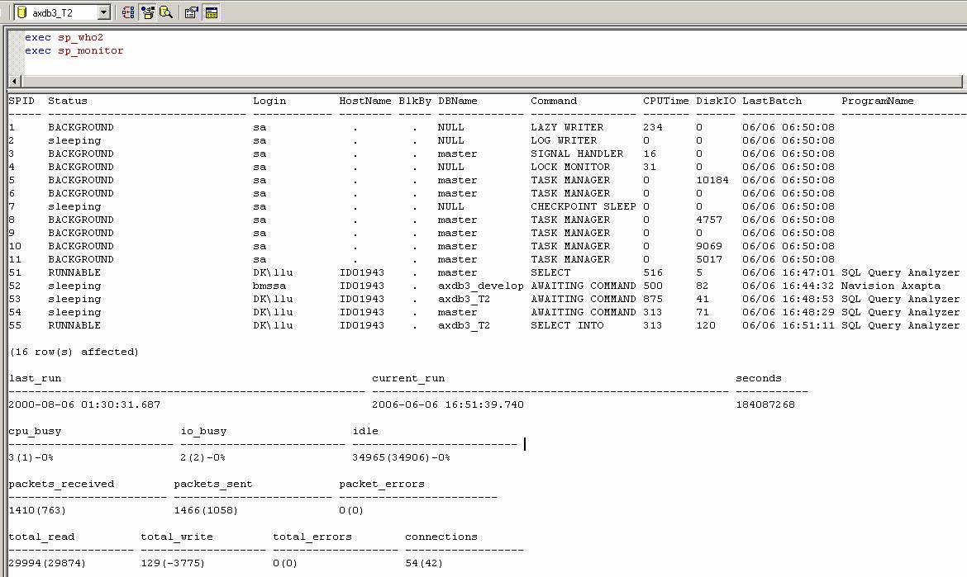

DBCC SHOWCONTIG: Displays fragmentation information for the data and indexes of the specified table
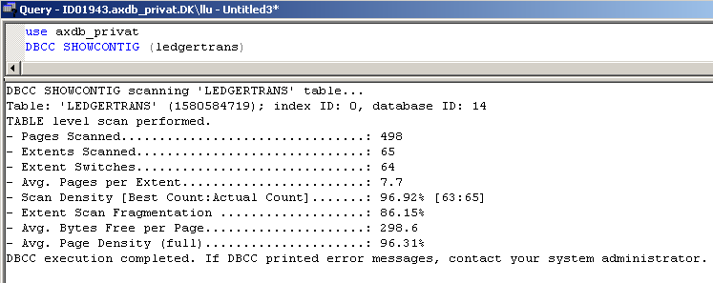

DBCC INDEXDEFRAG
Før Efter
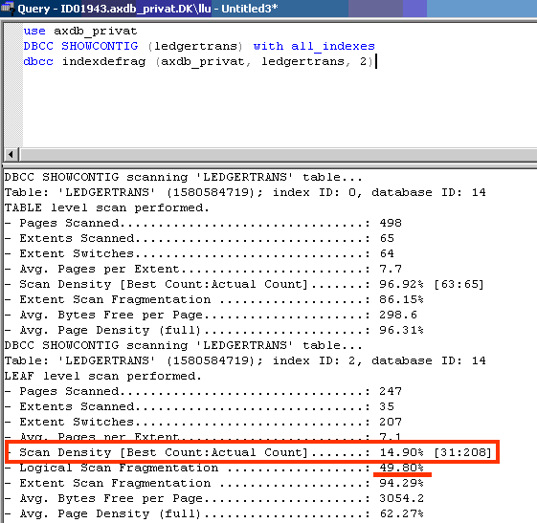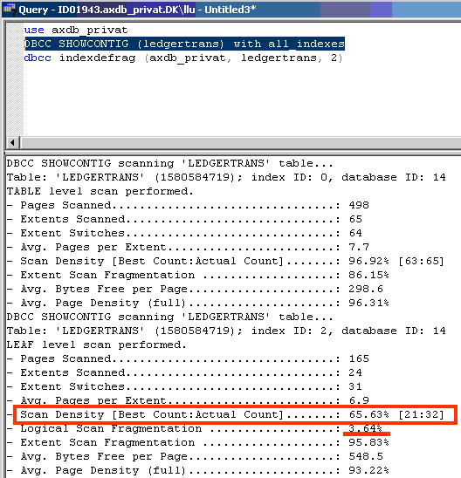
DECIMAL AFRUNDING

begin tran
select * from dbo.ledgerjournaltrans where journalnum = ' 79024' and voucher like '%D_6442959%' and dataareaid = 'KNI'
update ledgerjournaltrans set amountcurdebit = cast(amountcurdebit as dec(18,1)),amountcurcredit = cast(amountcurcredit as dec(18,1))
where journalnum = ' 79024' and voucher like '%D_6442959%' and dataareaid = 'KNI'
select * from dbo.ledgerjournaltrans where journalnum = ' 79024' and voucher like '%D_6442959%' and dataareaid = 'KNI'
rollback tran
select * from dbo.ledgerjournaltrans where journalnum = ' 79024' and voucher like '%D_6442959%' and dataareaid = 'KNI'
CHECKPOINT
DBCC DROPCLEANBUFFERS WITH NO_INFOMSGS
DBCC FREEPROCCACHE WITH NO_INFOMSGS

